Project Development Phase
Functional & Performance Testing

Date | 04 October 2026
Team ID | [Your Team ID]
Project Name | Script-Controlled ACL – Restrict Record Access Based on Field Value
Maximum Marks

Functional & Performance Testing – Script-Controlled ACL:
Project team shall fill the following information in the testing template.
S.No. | Parameter | Values | Screenshot
 | Test Summary | ServiceNow security setup: custom table with Branch field protected by read, create, write and delete ACLs (roles bb1–bb4). 9 test cases executed using impersonation of admin, EEE user and a no-role user. | 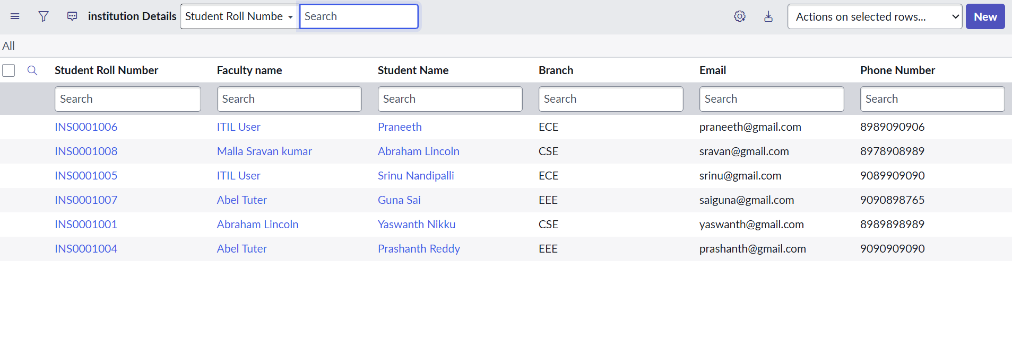  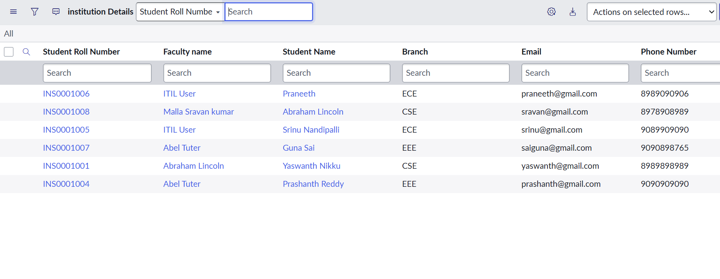
 | Access Decision Accuracy | Test cases passed: 9 / 9 (100%)  Unauthorised users shown records: 0  EEE user records visible: 2 of 2 EEE records; ECE/CSE records hidden | - 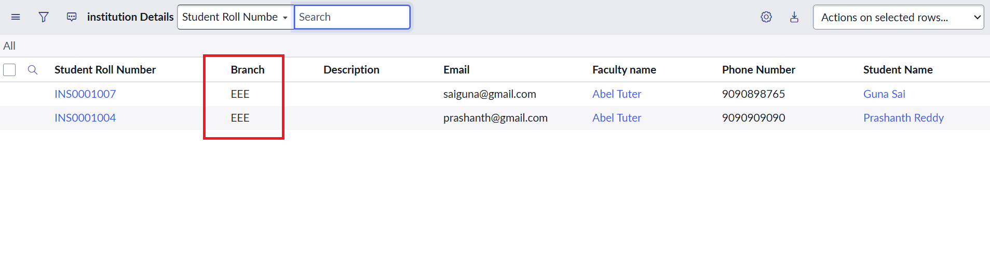  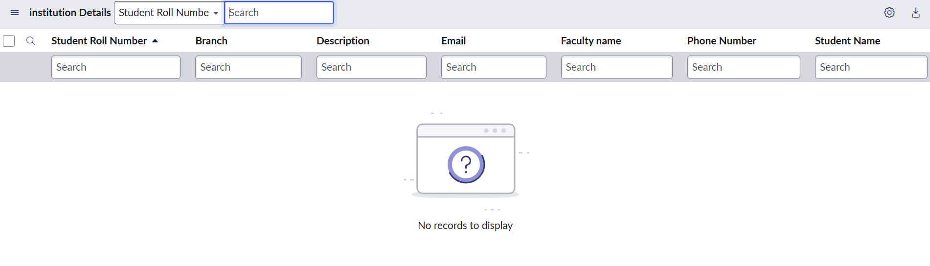
3. | Role / Operation Coverage | Read (bb1) ✔ Create (bb2) ✔ Write (bb3) ✔ Delete (bb4) ✔ Admin override ✔  ACL response is instant – list loads normally with ACLs enabled (no noticeable delay). | 